**How Health Expenditure Affects Health Outcomes in 51 Countries: Factors that influence health outcomes across the world**

David Oakes, Alex Orvis, Christopher McCormick, Pascaline Njouwou, Bryson Webb

Every year, most countries spend a significant portion of their gross domestic product (GDP) on the health and wellness of their citizens. Each country approaches the matter of financing and regulating this spending differently. This data analysis project aims to demonstrate how healthcare spending contributes to actual health outcomes. The group posed several questions to determine the relationship between health care spending methods and amounts and healthcare outcomes.

1. How does the amount of money a given country spends on healthcare affect their citizens’ actual health outcomes?
2. Are healthcare outcomes in the United States also better as a result of increased spending?
3. How to the percentages of people insured affect health care outcomes
4. Does the way each country finances healthcare costs affect health outcomes?
5. Why is healthcare spending in the United States proportionally so much higher than healthcare spending in similar countries?

**Data Overview**

This data largely came from OECD.stat1 who collect and distribute data on the economies and performance of many countries around the world. For the purposes of this project, data from 51 countries was used. Some data was also collected from World Bank.2 The same 51 countries were collected and analyzed from these data sets.

**Healthcare Expenditure**

Most countries spend a similar proportion of their GDP on healthcare. The above plot illustrates how each country’s GDP per capita relates to the health expenditure per capita. The **correlation coefficient** for this relationship was 0.83, which indicates that there is a strong positive relationship between GDP and healthcare expenditure. Most countries fall fairly closely to the linear regression indicated by the line **y = 0.1x - 13.52** with an **r-squared value of 0.69** indicating that 69% of the variability in the data is explained by the regression line. However, the dark green dot above the line represents the United States unusual healthcare spending. This deviation from the norm is the source of the group’s question: Why does the United States spend so much more money relative to their GDP than other countries and do its citizens have better health outcomes as a result? As one can see in Appendix 1, when healthcare expenditure measures are normalized by Purchasing Power Parity (PPP), the United States spends almost twice as much on health care per capita than the average for comparable countries.

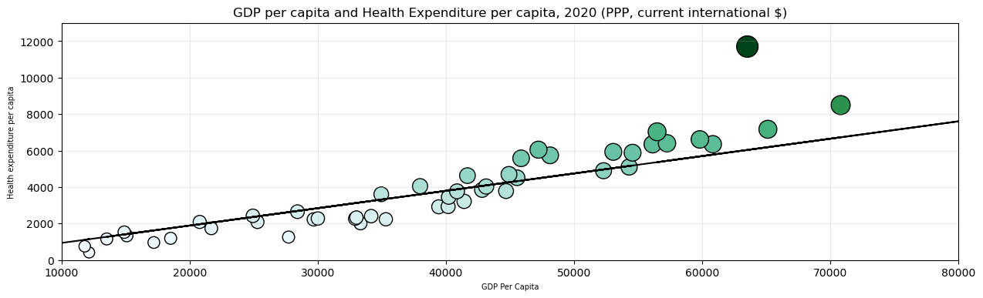

**Figure 1. GDP per capita relative to health expenditure per capita**

**Health Outcomes Relative to Expenditure**

The group analyzed health expenditure relative to five health outcomes: total population life expectancy (years), avoidable deaths per 100,000 population, infant mortality per 1,000 live births, maternal mortality per 100,000 live births, and deaths from heart disease per 100,000 population. Each of these outcomes are displayed below relative to percent of each of 51 country’s GDP expended on healthcare.

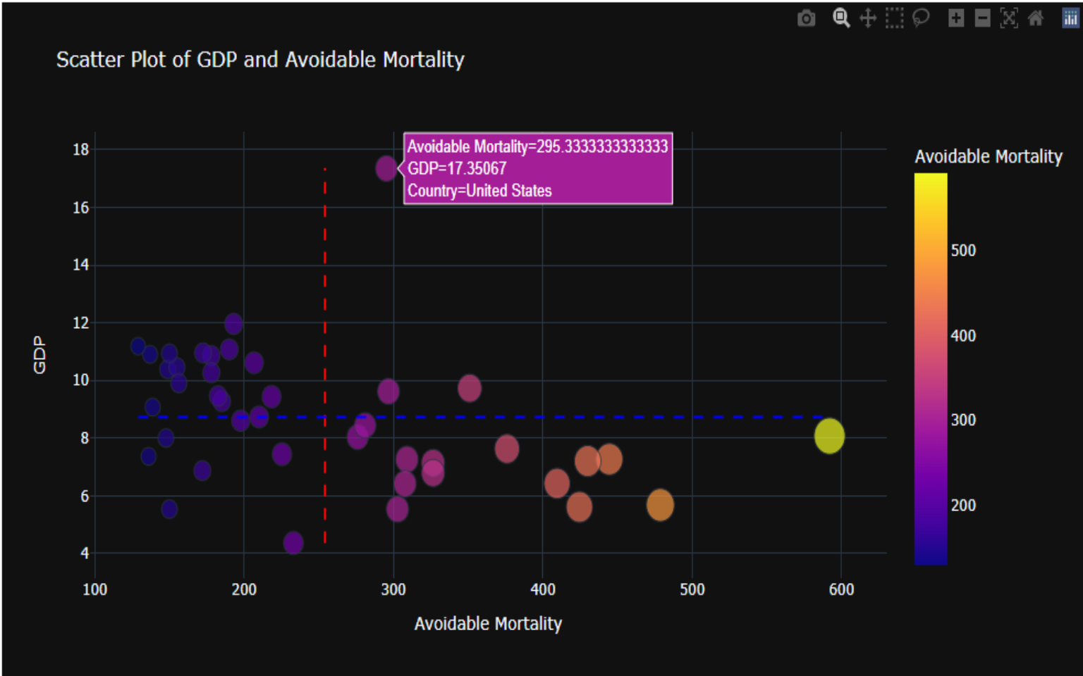

**Figure 2. Percentage GDP on health compared to avoidable mortality by country**

Figure 2 shows avoidable mortality (treatable and preventable deaths per 100,000 population) related to the percentage of GDP spent on healthcare. The dotted red line shows the average avoidable mortality, and the dotted blue line shows the average percentage of GDP spent on healthcare. The highest datapoint on the y-axis represents the United States, indicating that while the proportional health expenditure in the US is much higher than other countries, the avoidable mortality is only slightly less than the average. A t-test was performed for the relationship between the average avoidable mortality rate and the rate for the US and resulted in a p-value of 0.95, suggesting that the difference in rates between the US and all other countries was not statistically significant.

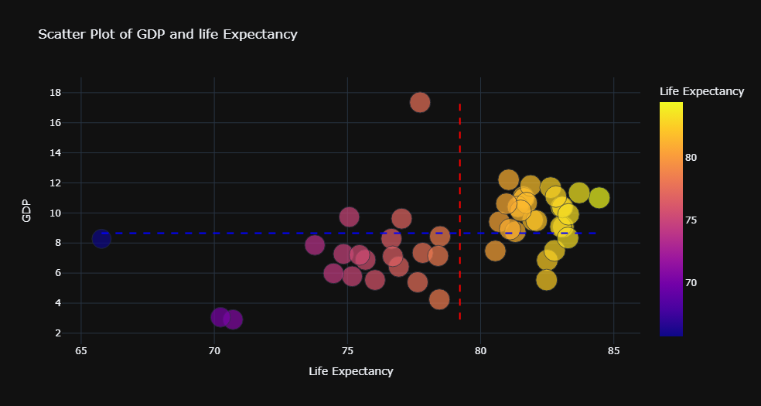

**Figure 3. Percentage GDP on health compared to life expectancy by country**

Figure 3 shows a similar outcome as figure 2. The US has exceptionally high health expenditure relative to below average life expectancy. A t-test was performed for the relationship between the average life expectancy and the life expectancy in the US and resulted in a p-value of 0.95, suggesting that the difference in rates between the US and all other countries was not statistically significant.

The remainder of the health outcomes can be found in the appendix, and most show similar results as the above two figures, with similarly insignificant p-values based on independent t-tests.

**Health Outcomes Relative to percent of the population insured**

The group wanted to explore the effect that health insurance had on health outcomes. We compared each country’s percentage of the population that was insured with each of the five aforementioned health outcomes and displayed them on scatter plots.

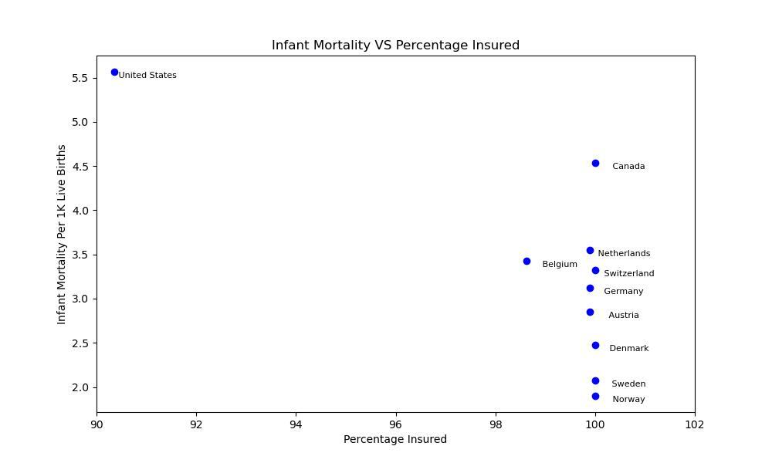

**Figure 4. Percentage of the population insured compared with infant mortality for the top ten highest health expenditure countries**

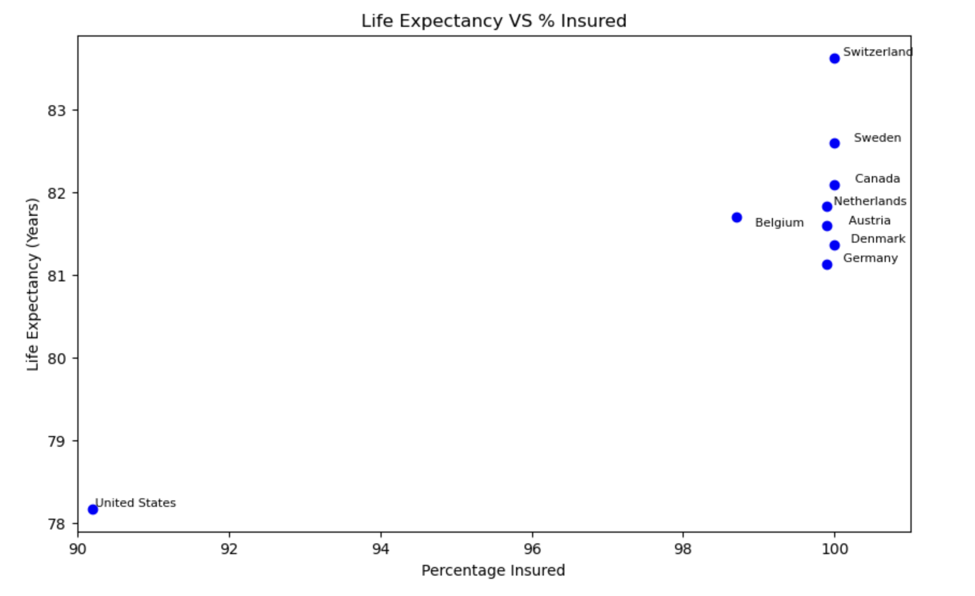

**Figure 5. Percentage of the population insured compared with life expectancy for the top ten highest health expenditure countries**

Broadly speaking, the overall well-being of a population tends to be positively correlated with the extent of insurance coverage within that demographic. As the percentage of individuals who are insured increases, there is a discernible improvement in health outcomes across the board. This connection underscores the vital role played by widespread insurance coverage in fostering and maintaining the health and wellness of a community. It is evident that a higher prevalence of insurance among the population contributes significantly to better health outcomes, reflecting the symbiotic relationship between comprehensive insurance and overall public health.

**Health Outcomes Relative to Financing Scheme**

Financing scheme is divided, broadly, into three categories. Government schemes enroll every citizen automatically and no direct payment is made for healthcare. Compulsory schemes obligate each citizen to enroll in a private or governmental health insurance plan and pay for that plan. Voluntary and household out of pocket payment schemes are direct payments form the patient to the healthcare provider.

Appendixdisplays a bar chart for all 51 countries illustrating their respective percentage of health in each of the three categories listed above. Figure 4shows this same data but for the top ten highest spending countries.

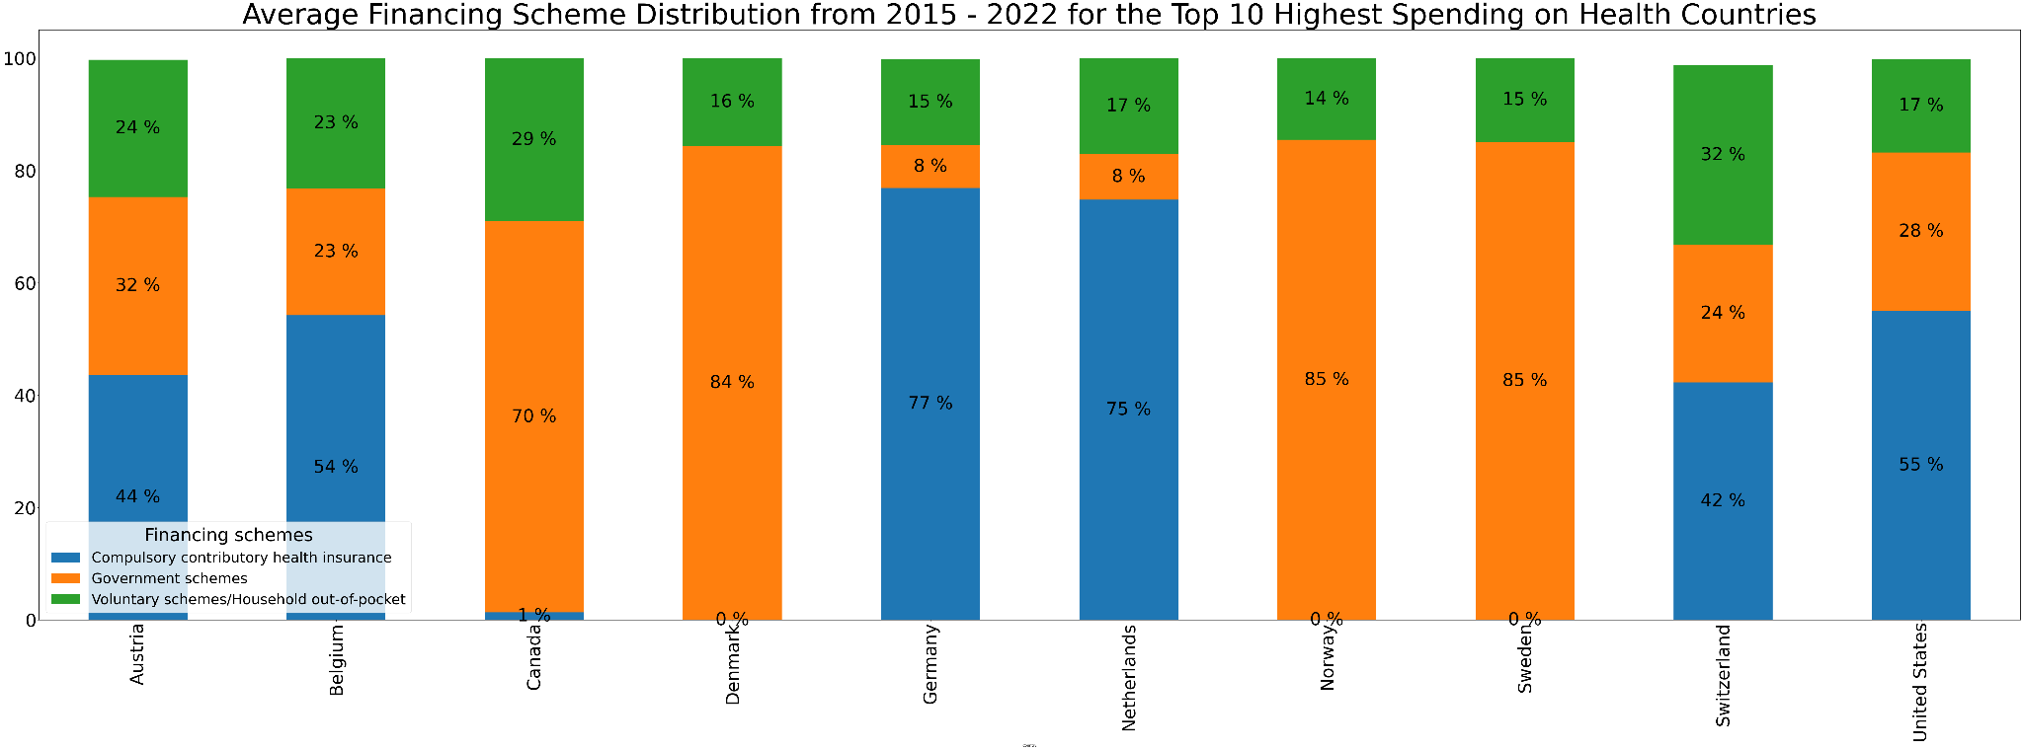

**Figure 6. The distribution of health care expenditure by financing scheme for the top ten highest health expenditure countries**

Each of the 51 listed countries were then assessed on the percentage of their health expenditure in each of the three given schemes, and plotted against the resulting health outcome as can be seen in the appendices. This data was also plotted for the top ten highest health expenditure countries, as seen below in figure 6.

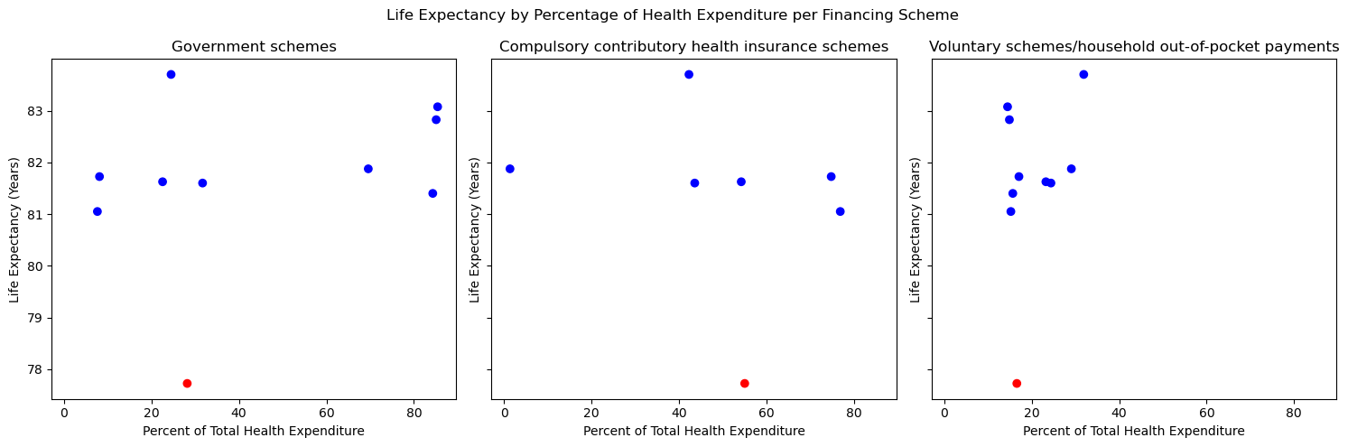

**Figure 7. Life expectancy compared with percent of health expenditure in each financing scheme across the top ten highest health expenditure countries.**

Correlation coefficients were calculated for the relationships between percentage of health expenditure on each financing scheme and various health outcomes. These correlation coefficients showed weak to very weak relationships between these variables. Additionally for each health outcome variable the ANOVA was calculated for the three financing schemes and all p-values showed that the variance between the three groups was most likely due to chance.

**Appendix**

1. Health expenditure in the United States relative to comparable countries (by GDP per capita), 2020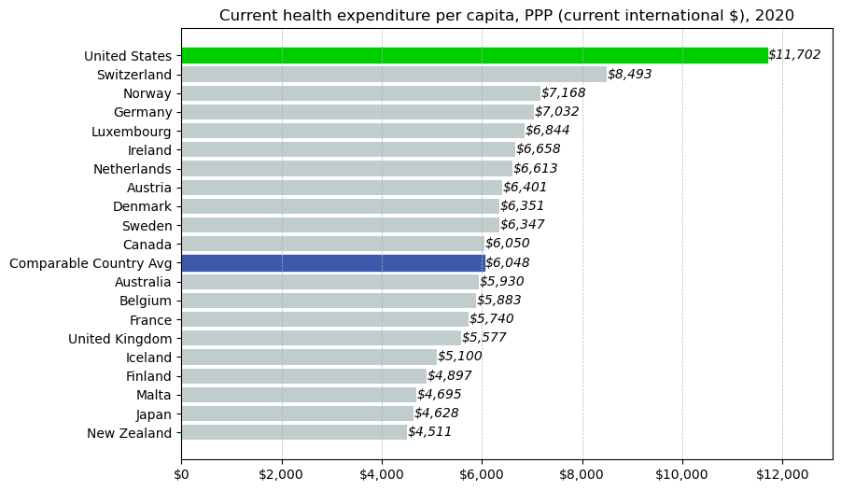

2. GDP per capita (2020)

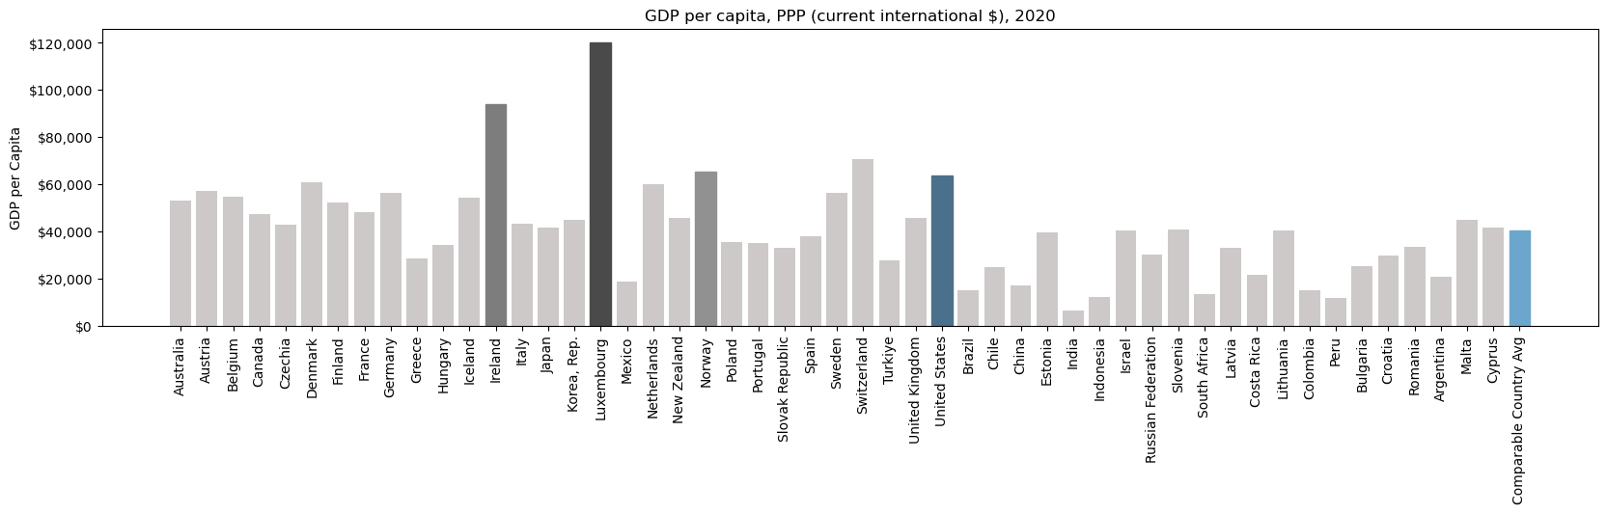

3. GDP per capita (2022)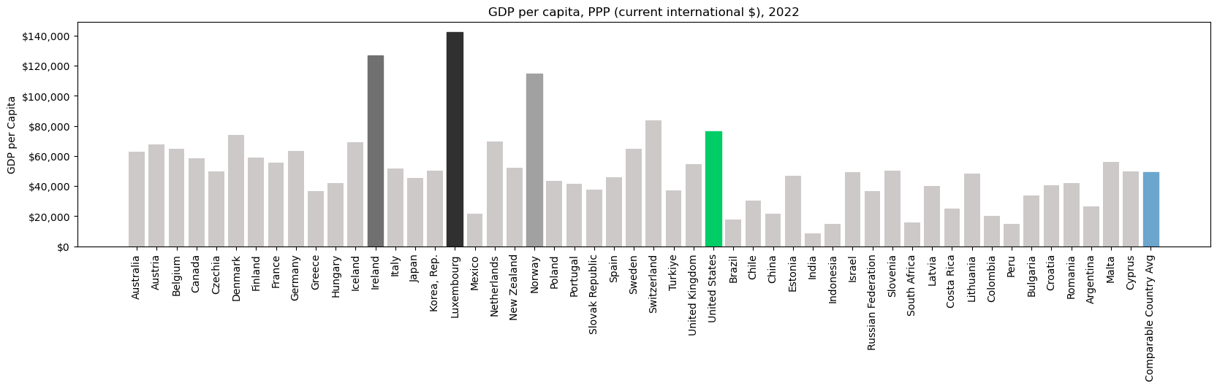

4. GDP per capita 2020, 2022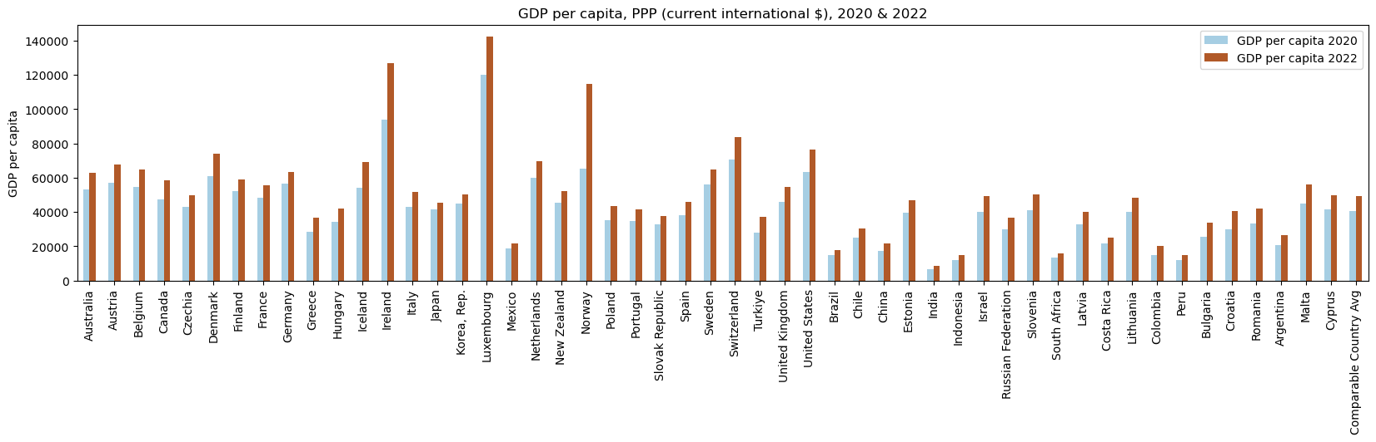

5. Current health expenditure as percentage of GDP (2020)

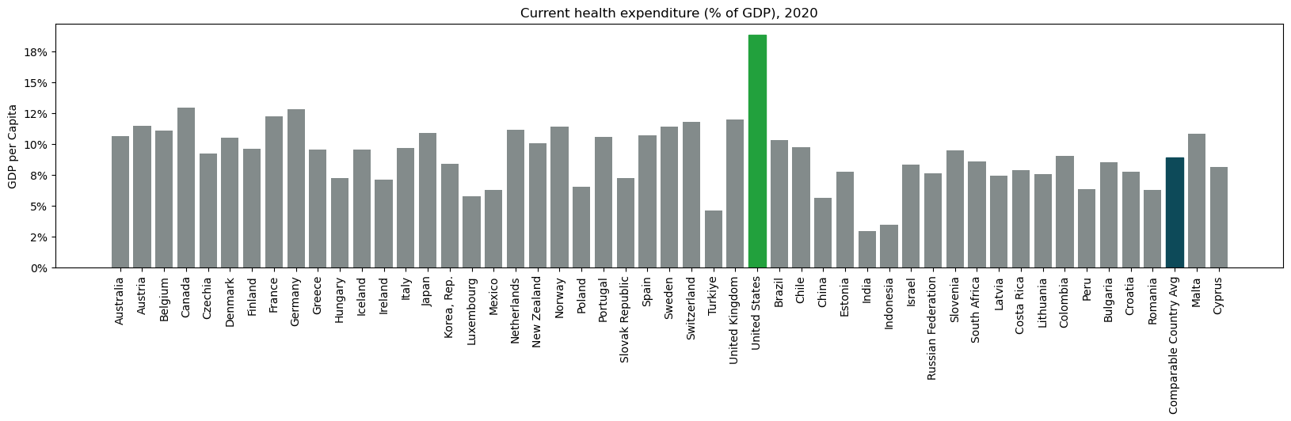

6.1 Health expenditure from 2000 to 2020

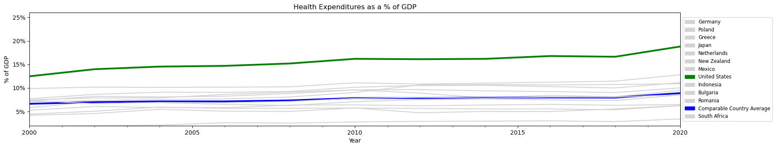

6.2

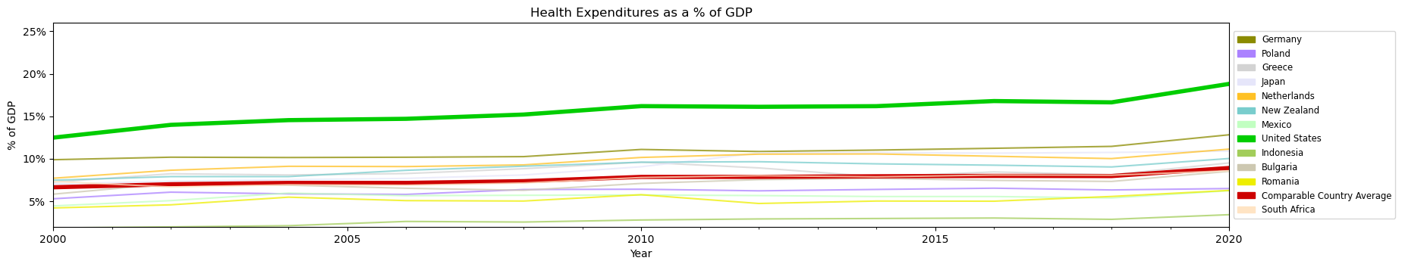

7. GDP percentage compared to infant mortality

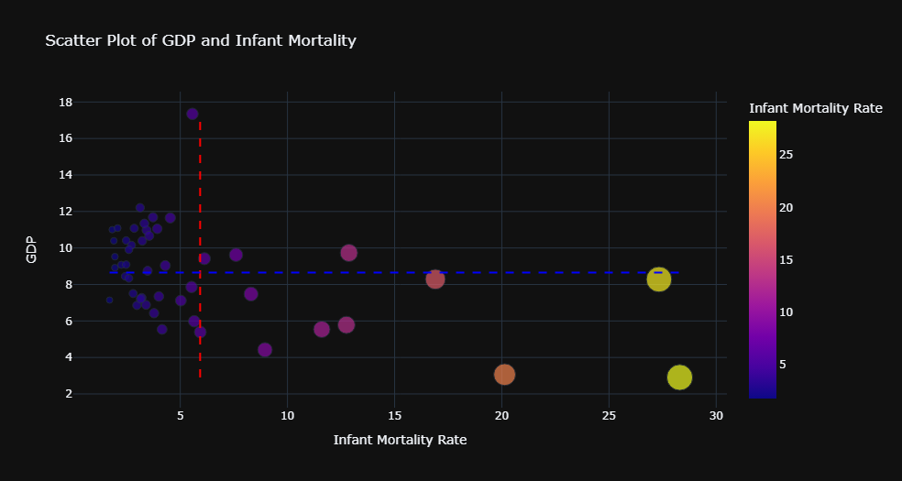

8. GDP percentage compared to maternal mortality

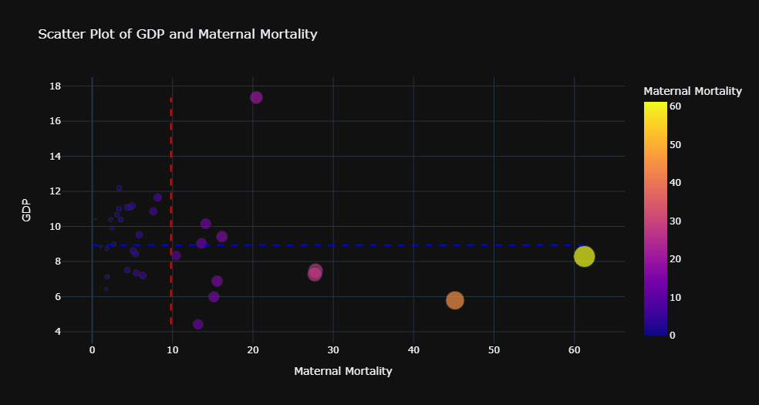

9. GDP percentage compared to heart disease

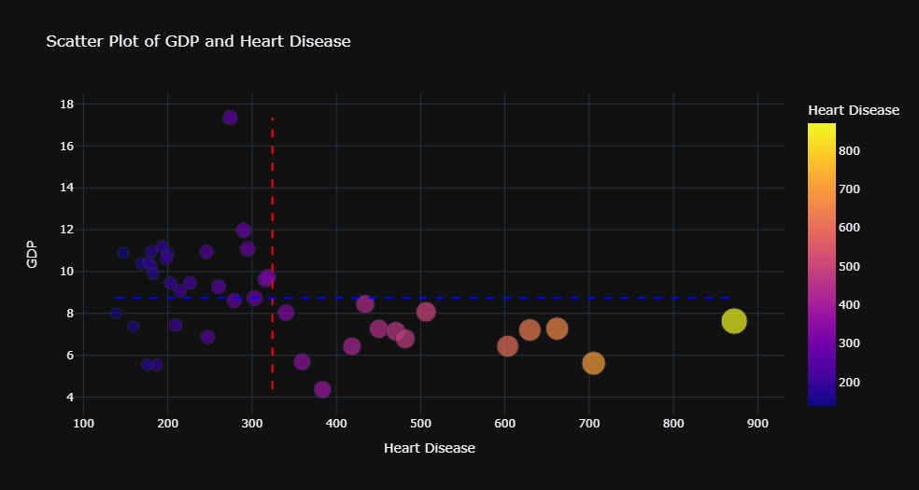

10. Average financing scheme from 2015 - 2022 for 51 countries

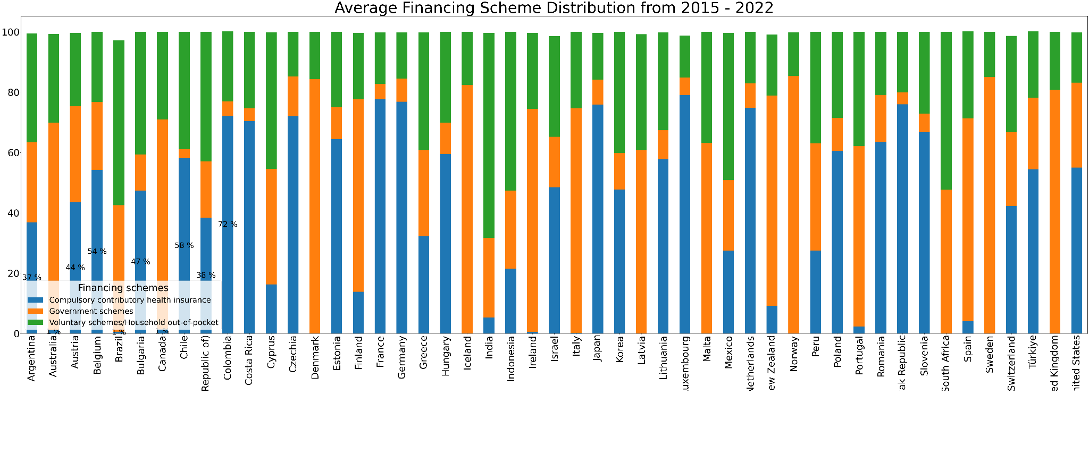

11. Average financing scheme expenditure from 2015 - 2022 for the countries spending the most on healthcare



12. Life expectancy relative to health financing scheme

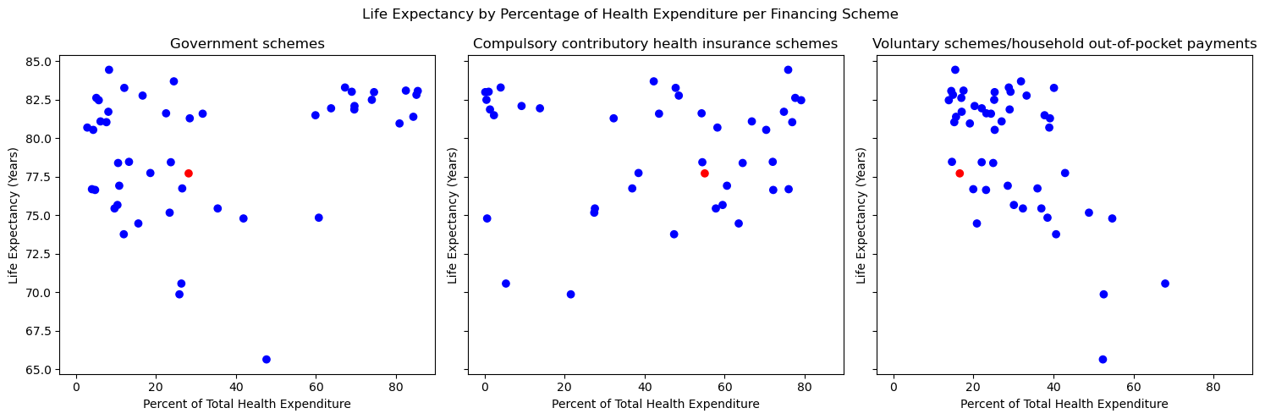

13. Avoidable deaths relative to healthcare financing scheme

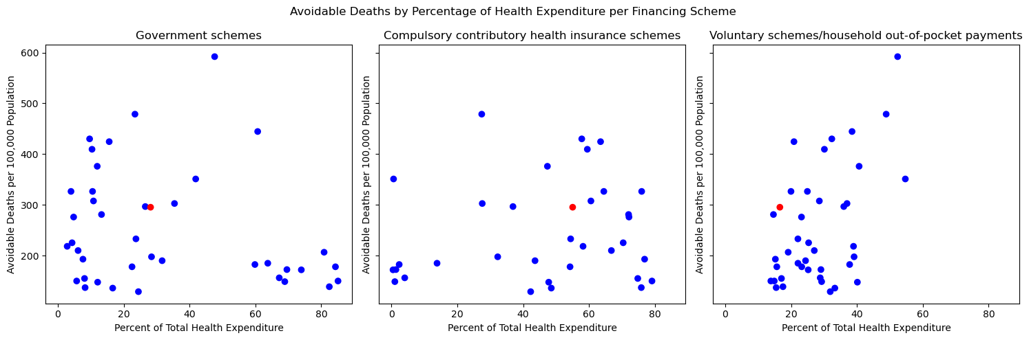

14. Avoidable deaths relative to healthcare financing scheme for the top ten highest spending countries

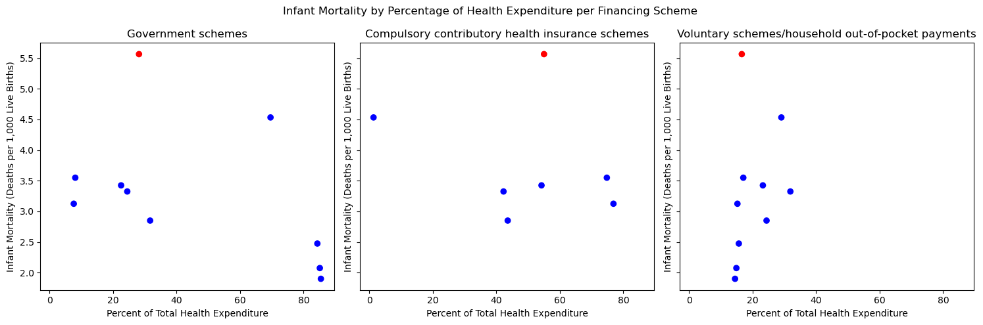

15. Infant mortality relative to healthcare financing scheme

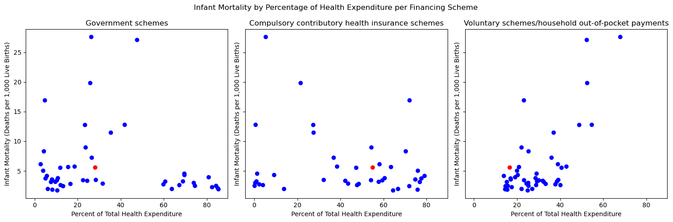

16. Infant mortality relative to healthcare financing scheme for the top ten highest spending countries



17. Maternal mortality relative to healthcare financing scheme

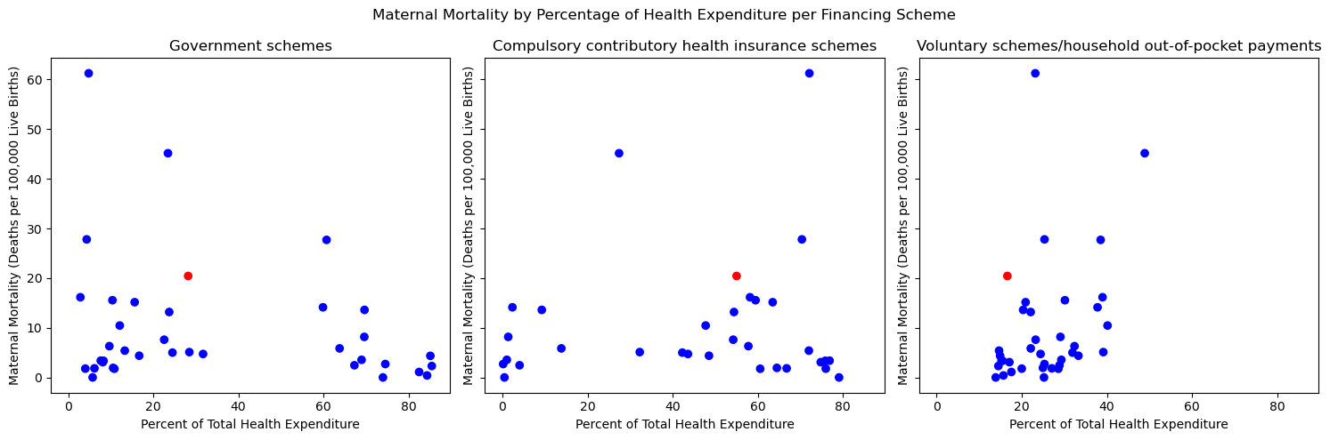

18. Maternal mortality relative to healthcare financing scheme for the top ten highest spending countries

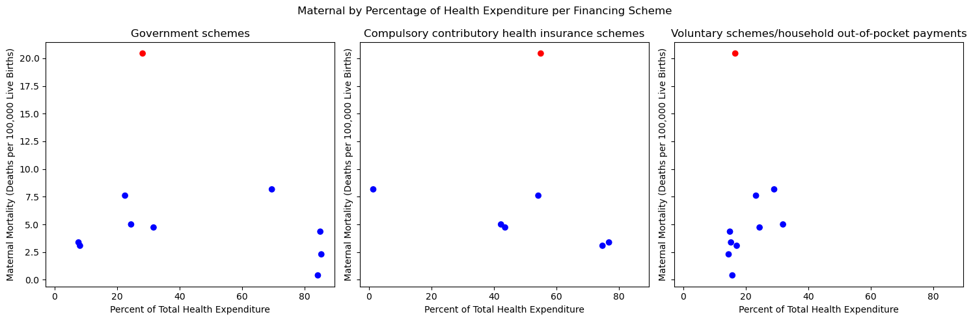

19. Death from heart disease relative to healthcare financing scheme

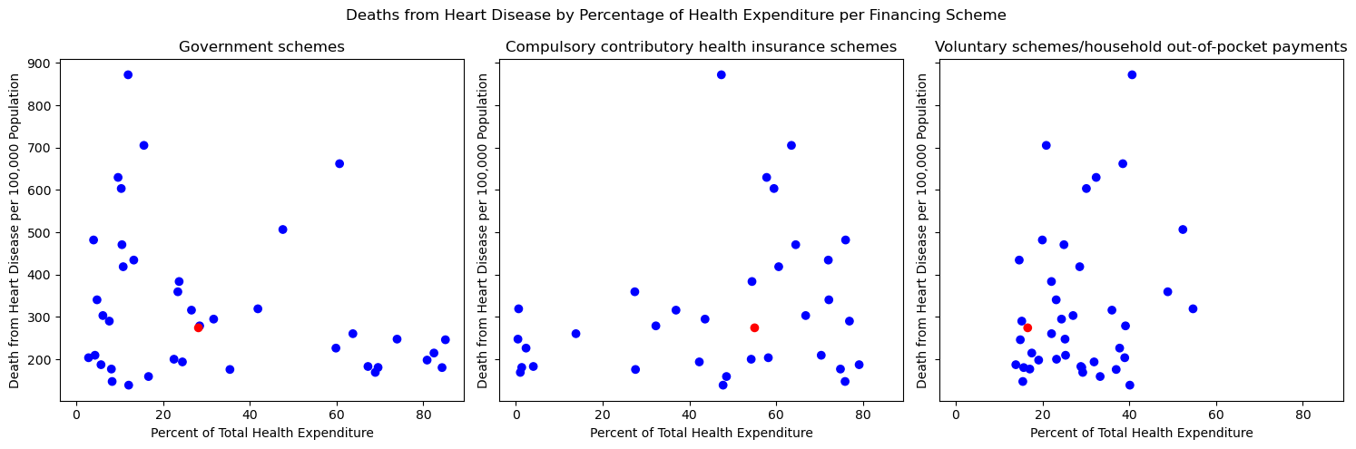

20. Death from heart disease relative to healthcare financing scheme for the top ten highest spending countries

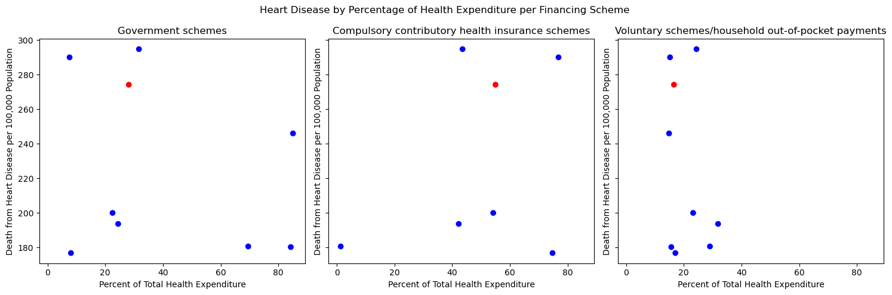

**Resources**

1. <https://stats.oecd.org/>

Primary data tables showing health outcomes and expenditures was from OECD.stat

1. https://databank.worldbank.org/reports.aspx?source=2&series=SH.XPD.CHEX.PC.CD&country=#

Data for the country’s GDP and health expenditure for some of the figures was obtained from World Bank.

1. <https://www.cms.gov/data-research/statistics-trends-and-reports/national-health-expenditure-data/historical>

This article was the primary source for the original research question.